ENGLISH READING BADGE
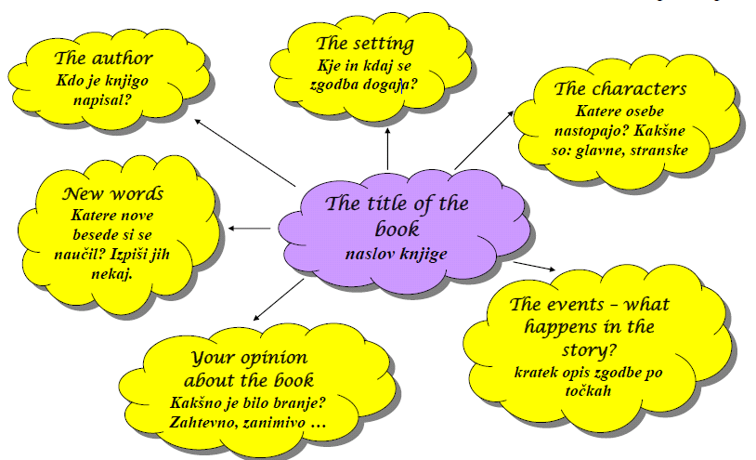

THE TITLE:__________________________________________________________________________
AUTHOR: __________________________________________________________________________
THE SETTING: _______________________________________________________________________
CHARACTERS:_______________________________________________________________________
__________________________________________________________________________________
__________________________________________________________________________________
THE EVENTS - WHAT HAPPENS IN THE STORY: _________________________________________
___________________________________________________________________________
__________________________________________________________________________________
__________________________________________________________________________________
__________________________________________________________________________________
__________________________________________________________________________________
__________________________________________________________________________________
__________________________________________________________________________________
__________________________________________________________________________________
__________________________________________________________________________________
__________________________________________________________________________________
YOUR OPINION:_____________________________________________________________________
________________________________________________________________________________________________________________________________________________________________________________________________________________________________________________________________________________________________________________________________________________________________________________________________________________________________________________________________________________________________________________________________________________________________________________________________________________________________________________________________________________
NEW WORDS: ______________________________________________________________________
__________________________________________________________________________________
__________________________________________________________________________________
__________________________________________________________________________________

Name and surname:_______________________ Class:_____ Date:_____________

